Temasek Polytechnic
School of Informatics and IT

Diploma in Information Technology (IT)
AY2013/2014 Apr Semester Level 3

Design Specifications (DS)

Project Particulars

Tutor | Ms Serena Tai
Class | P02
Project Title | Delonix Regia Hotel Management System

Project Team’s Particulars

Matric Number | Student Name
1101387G | Chua Edwin
1101137F | Marvin Koh
1105342H | Leonard Choo

Revision History

Date | Version | Description | Author
<dd/mm/yy> | <x.x> | <details> | <name>

Table of Contents

1. DISTRIBUTION OF WORKLOAD 4
2. ARCHITECTURE DESIGN 4
3. USER INTERFACE (UI) DESIGN 45
4. PROGRAM DESIGN 45
5. DATABASE DESIGN 47

DISTRIBUTION OF WORKLOAD

[Determine which members of the team will be responsible for which areas of design. Individual’s responsibilities should be clearly spelt out.]

Design | Members
1 | All
2, 5 | Edwin
3 | Leonard
4 | Marvin

ARCHITECTURE DESIGN

The proposed system architecture for Delonix Regia Hotel Management System will be a 2-tier architecture.

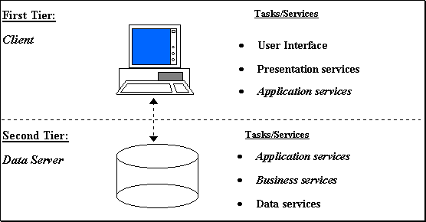

The first tier will be where the application is stored or runned, this will be the single computer of the hotel.

The second tier will be the data service where all the data are kept at. The data will be kept on the same computer where the application is being runned, this will ensure the fastest time taken to access the data required.

USER INTERFACE (UI) DESIGN

Is web or windows or other forms of UI used?
Windows UI is used.

Why did you choose that particular UI?
I have chosen my current UI because it is simple and widely used, if the project is passed-over to new work partners they would still know how to modify it.

Why did you choose that particular UI?
The design impacts usability making it user-friendly and intuitive.

Why adopt certain UI controls than others?
Certain UI controls conform to existing UI controls and being widely use it enables a simpler search for UI control manipulations.
Firstly users will be able to recognize these controls and roughly know its function having previously gone thru an experience using it before.
Secondly it helps prevent misconception and misuse of functions.
Lastly users may not be tech-savvy and habitual users of the latest UI controls.

PROGRAM DESIGN

Each function serves a purpose. The functions were filtered out from the standard CRUD.

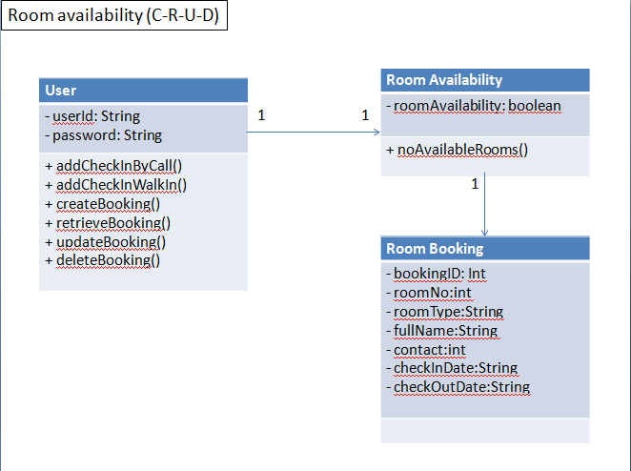
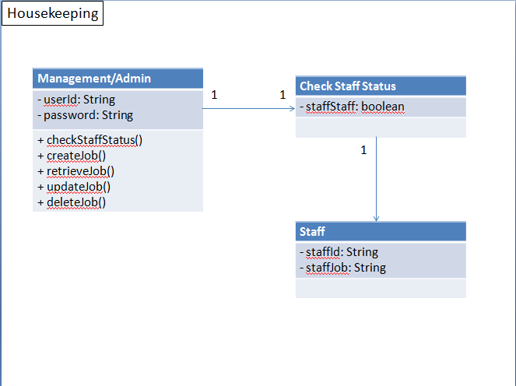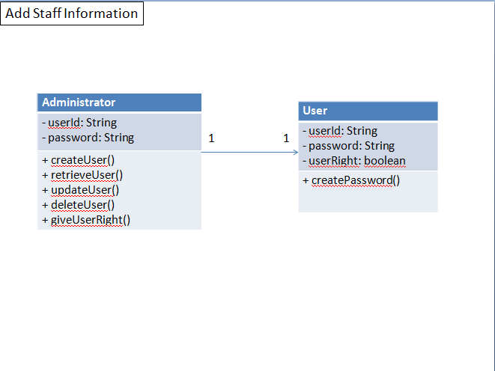

DATABASE DESIGN

ERD Diagram
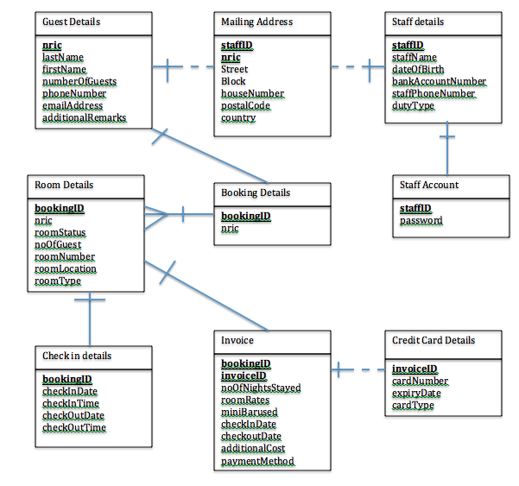

Data Dictionary

Table Name | Column Name | Data Type | Null Option | Column is PK | Column is FK | Comment
Guest Details | nric | Varchar(10) | Not NULL | Yes | No
Guest Details | lastName | Varchar(25) | Not NULL | No | No
Guest Details | firstName | Varchar(25) | Not NULL | No | No
Guest Details | numberOfGuest | Int | Not NULL | No | No
Guest Details | phoneNumber | Varchar(15) | Not NULL | No | No
Guest Details | emailAddress | Varchar(30) | Not NULL | No | No
Guest Details | addtionalRemarks | Varchar(100) | NULL | No | No

Table Name | Column Name | Data Type | Null Option | Column is PK | Column is FK | Comment
Staff Details | staffID | Char(3) | Not NULL | Yes | No
Staff Details | staffName | Varchar(25) | Not NULL | No | No
Staff Details | dateOfBirth | date | Not NULL | No | No
Staff Details | bankAccountNumber | Varchar(15) | Not NULL | No | No
Staff Details | staffPhoneNumber | Varchar(15) | Not NULL | No | No
Staff Details | dutyType | Char(2) | Not NULL | No | No

Table Name | Column Name | Data Type | Null Option | Column is PK | Column is FK | Comment
Mailing Address | staffID | Char(3) | Not NULL | Yes | Yes
Mailing Address | nric | Varchar(10) | Not NULL | Yes | Yes
Mailing Address | Street | Varchar(30) | Not NULL | No | No
Mailing Address | Block | Varchar (6) | Not NULL | No | No
Mailing Address | houseNumber | Varchar(6) | Not NULL | No | No
Mailing Address | postalCode | Varchar(15) | Not NULL | No | No
Mailing Address | country | Varchar(60) | Not NULL | No | No

Table Name | Column Name | Data Type | Null Option | Column is PK | Column is FK | Comment
Room Details | bookingID | Varchar(10) | Not NULL | Yes | Yes
Room Details | nric | Varchar(10) | Not NULL | Yes | Yes
Room Details | roomStatus | Varchar(30) | Not NULL | No | No
Room Details | noOfGuest | Char(2) | Not NULL | No | No
Room Details | roomNumber | Varchar(6) | Not NULL | No | No
Room Details | roomLocation | Varchar(15) | Not NULL | No | No
Room Details | roomType | Varchar(30) | Not NULL | No | No

Table Name | Column Name | Data Type | Null Option | Column is PK | Column is FK | Comment
Checkindetails | bookingID | Varchar(10) | Not NULL | Yes | Yes
Checkindetails | checkInDate | date | Not NULL | No | No
Checkindetails | checkInTime | time | Not NULL | No | No
Checkindetails | checkOutDate | date | Not NULL | No | No
Checkindetails | checkOutTime | time | Not NULL | No | No

Table Name | Column Name | Data Type | Null Option | Column is PK | Column is FK | Comment
Invoice | bookingID | Varchar(10) | Not NULL | Yes | Yes
Invoice | invoiceID | Varchar(10) | Not NULL | Yes | No
Invoice | noOfNightsStayed | int | Not NULL | No | No
Invoice | roomRates | int | Not NULL | No | No
Invoice | miniBarused | Char(3) | Not NULL | No | No
Invoice | checkInDate | date | Not NULL | No | No
Invoice | checkoutDate | date | Not NULL | No | No
Invoice | additionalCost | int | NULL | No | No
Invoice | paymentMethod | Varchar(10) | Not NULL | No | No

Table Name | Column Name | Data Type | Null Option | Column is PK | Column is FK | Comment
Credit Card Details | invoiceID | Varchar(10) | Not NULL | Yes | Yes
Credit Card Details | cardNumber | Char(16) | Not NULL | Yes | Yes
Credit Card Details | expiryDate | Char(5) | Not NULL | No | No
Credit Card Details | cardType | Char(10) | Not NULL | No | No

Table Name | Column Name | Data Type | Null Option | Column is PK | Column is FK | Comment
Booking Details | bookingID | Varchar(10) | Not NULL | Yes | Yes
Booking Details | nric | Varchar(10) | Not NULL | Yes | Yes

Table Name | Column Name | Data Type | Null Option | Column is PK | Column is FK | Comment
Staff Account | staffID | Char(3) | Not NULL | Yes | Yes
Staff Account | password | Varchar(30) | Not NULL | No | No

Some considerations that went into the database schema was to make the database simple yet without much redunant classes, as well as a sound logic with the flow.

